Navigating the Digital Frontier: Strategic Prioritization of Mobile Apps Versus Websites in E-Commerce

Vaishnavi Pande

[2021bit056@sggs.ac.in](mailto:2021bit056@ac.in)

Guided by: **Dr. Ankush Sawarkar**

Department of Information Technology, Shri Guru Gobind Singhji Institute of Engineering and Technology (SGGSIET), Nanded

# 

# Abstract

In the realm of digital commerce, businesses face a critical decision regarding resource allocation between enhancing their mobile app experience and optimizing their website. This decision carries significant implications for customer engagement, satisfaction, and ultimately, business success. This research paper delves into the strategic choice confronting companies as they navigate the dynamic landscape of e-commerce. Through an exploration of customer preferences, usage patterns, and industry trends, this paper aims to provide valuable insights into the factors influencing the prioritization of mobile apps versus websites. By analyzing real-world case studies and emerging best practices, this paper offers actionable recommendations for companies seeking to maximize their online presence and drive sustainable growth in the competitive digital marketplace. Our study investigates the effectiveness of various regression algorithms in predicting Yearly Amount Spent by customers of an e-commerce company based on their characteristics. The analysis involves the evaluation of four regression algorithms: Linear Regression, Ridge Regression and Lasso Regression. Findings indicate that Linear Regression emerged as the best-performing algorithm, achieving a test score of 0.9826 and demonstrating the ability to explain approximately 98.2% of the variance in the target variable.

**Keywords:**

Mobile Applications, Website Optimization, E-commerce, Consumer Preferences, User Engagement, Retention, Conversion Rates, Revenue Generation, Technical Considerations, Resource Allocation, Strategic Decision-Making, Digital Commerce, Regression Modeling, Customer Spending Prediction.

# Introduction:

Machine learning regression is a fundamental technique in predictive modeling that plays a pivotal role in understanding and forecasting continuous outcomes. Unlike classification, which deals with discrete categories, regression aims to predict a continuous numerical value based on input features. This technique holds immense importance across various domains, from finance and healthcare to marketing and beyond, owing to its ability to provide valuable insights and make accurate predictions [1].

At its core, regression analysis seeks to identify and model the relationship between one or more independent variables and a dependent variable. By analyzing historical data, regression algorithms learn patterns and associations, enabling them to predict future outcomes with a certain degree of confidence. This predictive capability empowers decision-makers to make informed choices, optimize strategies, and allocate resources effectively [1] [2].

In the digital age, where online presence is crucial for businesses to thrive, the dilemma of allocating resources between mobile applications and website development poses a significant challenge. For companies operating in the e-commerce sector, such decisions carry substantial implications for customer engagement, satisfaction, and ultimately, profitability. This research paper aims to explore and analyze the strategic choice facing a company torn between investing in enhancing either its mobile app experience or its website to better cater to its target audience and achieve its business objectives effectively [2] [3].

With the exponential growth of mobile device usage and the pervasive nature of smartphones in consumers' daily lives, the mobile app landscape has become increasingly competitive. Companies are grappling with the decision of whether to prioritize the optimization of their mobile applications to capitalize on this trend or to continue refining their website to maintain a strong online presence across all platforms. Understanding the nuances of customer preferences, usage patterns, and engagement metrics is essential for making informed decisions regarding resource allocation and strategic planning [2].

On one hand, mobile apps offer a more immersive and personalized user experience, with features such as push notifications, location-based services, and seamless integration with device functionalities. These attributes can enhance user engagement, foster brand loyalty, and drive repeat purchases, making mobile apps an attractive avenue for companies seeking to deepen their relationship with customers and maximize lifetime value [3].

On the other hand, websites remain a cornerstone of online business operations, serving as the primary touchpoint for customers to browse products, make purchases, and access essential information. Investing in website optimization ensures a seamless and intuitive user interface, fast loading times, and cross-device compatibility, thereby catering to a broader audience and improving overall accessibility [2] [4].

However, the decision to prioritize either the mobile app experience or the website is not without its challenges and trade-offs. Factors such as development costs, technical complexity, time-to-market, and resource constraints must be carefully weighed against potential benefits and returns on investment. Additionally, market dynamics, consumer preferences, and industry trends play a pivotal role in shaping strategic decisions and driving competitive advantage in the digital landscape [2] [5].

In light of these considerations, this research paper seeks to delve into the intricacies of the mobile app versus website dilemma, examining the underlying factors influencing companies' strategic choices and their implications for customer engagement, retention, and revenue generation. By analyzing real-world case studies, industry benchmarks, and emerging trends, this paper aims to provide valuable insights and actionable recommendations for companies navigating the complex terrain of digital commerce in an ever-evolving marketplace [1] [3] [4].

# Literature Review:

The debate surrounding the prioritization of mobile applications versus websites in the context of e-commerce has garnered significant attention in both academic research and industry discourse. A thorough review of existing literature reveals a nuanced understanding of the factors influencing this strategic decision and its implications for businesses and consumers alike [1] [5].

1. **Consumer Preferences and Usage Patterns:** Studies by Lien et al. (2018) and Liang et al. (2019) have investigated consumer preferences and usage patterns concerning mobile apps and websites in the e-commerce domain. Lien et al. found that younger demographics tend to favor mobile apps for their convenience and personalized experiences, while Liang et al. highlighted the importance of website accessibility and usability for older consumers. These findings underscore the need for companies to consider demographic factors and user preferences when determining their digital strategy [6].
2. **User Engagement and Retention:** Research by Chen et al. (2016) and Kim et al. (2020) has examined the impact of mobile app and website features on user engagement and retention. Chen et al. identified push notifications and in-app rewards as effective strategies for increasing user engagement in mobile apps, while Kim et al. emphasized the role of website design and navigation in enhancing user retention. These studies emphasize the importance of tailoring digital experiences to align with user expectations and preferences to foster long-term customer relationships [6].
3. **Conversion Rates and Revenue Generation:** The relationship between mobile app adoption, website optimization, and conversion rates has been explored by Xu et al. (2017) and Zhang et al. (2021). Xu et al. found that companies with well-designed mobile apps experienced higher conversion rates and revenue growth compared to those without mobile app presence. Similarly, Zhang et al. highlighted the positive correlation between website performance metrics, such as page load speed and checkout process efficiency, and conversion rates. These findings underscore the direct impact of digital platform optimization on business outcomes and revenue generation [7].
4. **Technical Considerations and Resource Allocation:** Technical considerations and resource allocation strategies have been examined by Sharma et al. (2018) and Wang et al. (2020). Sharma et al. emphasized the importance of aligning development resources with customer needs and market demand when deciding between mobile apps and websites. Wang et al. further explored the cost-benefit analysis of mobile app development versus website optimization, highlighting the trade-offs between upfront investment and long-term returns. These studies provide valuable insights into the strategic decision-making process and resource allocation strategies employed by companies in the e-commerce sector.

In summary, the literature underscores the multifaceted nature of the mobile app versus website dilemma in e-commerce, with factors such as consumer preferences, user engagement, conversion rates, and resource allocation playing pivotal roles in shaping strategic decisions. By synthesizing insights from existing research, this literature review sets the stage for further exploration and analysis in this dynamic and evolving field [7] [8][9].

# Methodology:

### Data Collection:

The dataset used in this study is sourced from "Ecommerce Customers.csv". It contains information on various customer attributes such as average session length, time spent on the app and website, length of membership, and yearly amount spent. The dataset consists of 500 entries with no missing values [10] .

### Data Preprocessing:

The dataset underwent preprocessing to facilitate analysis, starting with renaming columns to remove spaces and periods for ease of access and manipulation. Feature engineering was applied to create meaningful features, specifically renaming "Time_on_App" to "App_Usage," "Time_on_Website" to "Website_Usage," and "Length_of_Membership" to "Membership_Length." Subsequently, exploratory data analysis (EDA) was conducted, including correlation analysis and scatter matrix visualization, to understand relationships between variables and identify patterns within the data [7] [8] [10].

### Model Selection:

The selection of the regression algorithm was based on its suitability for predicting the continuous target variable, which in this case is the "Yearly_Spent" column. The Linear Regression algorithm was chosen due to its simplicity, interpretability, and effectiveness in capturing linear relationships between features and the target variable [9][10].

### Machine learning models:

In this section, we describe the machine learning models used in this study, along with their mathematical foundations.

1. **Linear Regression**

Linear regression aims to model the relationship between a dependent variable 𝑦and one or more independent variables 𝑋. The model assumes a linear relationship between the dependent variable and the independent variables. The mathematical representation is:

𝑦=𝛽0+𝛽1𝑥1+𝛽2𝑥2+⋯+𝛽𝑛𝑥𝑛+𝜖*y*=*β*0​+*β*1​*x*1​+*β*2​*x*2​+⋯+*βn*​*xn*​+*ϵ*

1. **Ridge Regression**

Ridge regression is a regularized version of linear regression that includes a penalty term to shrink the coefficients and prevent overfitting. The objective function to minimize is:

$${min⁡}_{β}\left\{\sum_{i=1}^{n}{{(y_{i}-β_{0}-\sum_{j=1}^{p}{β_{j}x_{ij})}}^{2}+α\sum_{j=1}^{p}{β_{j}^{2}}}\right\}$$

where, α is the regularization parameter that controls the amount of shrinkage applied to the coefficients.

1. **Lasso Regression**

Lasso regression (Least Absolute Shrinkage and Selection Operator) is another regularized version of linear regression that uses an L1 penalty to shrink some coefficients to zero, effectively performing variable selection. The objective function is:

$${min⁡}_{β}\left\{\sum_{i=1}^{n}{{(y_{i}-β_{0}-\sum_{j=1}^{p}{β_{j}x_{ij})}}^{2}+α\sum_{j=1}^{p}{|β_{j}^{1}|}}\right\}$$

# Experimental Setup:

### Model Implementation:

The regression models were implemented using Python programming language along with several popular software libraries for machine learning and data analysis. Specifically, we utilized NumPy and pandas for data manipulation and preprocessing, matplotlib and seaborn for data visualization, scikit-learn for model training and evaluation, and XGBoost and LightGBM for gradient boosting machine models. Additionally, the imbalanced-learn library was employed for dealing with class imbalance in the dataset. The computational resources utilized for model implementation included a standard laptop with adequate processing power and memory capacity [2] [6].

### Hyperparameter Tuning:

Hyperparameter tuning was performed using the **GridSearchCV** class from the Scikit-learn library. This involved defining a grid of hyperparameter values for the selected regression algorithm (Linear Regression) and exhaustively searching through the grid to find the optimal combination of hyperparameters that maximizes model performance [1] [3] [8].

### Cross-Validation:

Cross-validation was employed to ensure the robustness and generalizability of the model. Specifically, K-fold cross-validation with 5 folds was utilized. This involved splitting the dataset into 5 equally sized subsets, training the model on 4 subsets, and evaluating its performance on the remaining subset. This process was repeated 5 times, with each subset serving as the validation set exactly once. The final performance metrics were averaged across all folds to obtain an overall assessment of model performance. This methodology helps to mitigate overfitting and provides a more reliable estimate of the model's performance on unseen data [1] [3] [11].

# Results:

|  |  |  |  |
| --- | --- | --- | --- |
| **Model** | **Train score** | **Test score** | **Error Ratio** |
| **Linear Regerssion** | 0.98460 | 0.9826 | 0.9219 |
| **Ridge Regression** | 0.9846 | 0.9826 | 0.9221 |
| **Lasso Regression** | 0.9845 | 0.9825 | 0.9266 |

The best algorithm is Linear Regression with a test score of **0.9826**

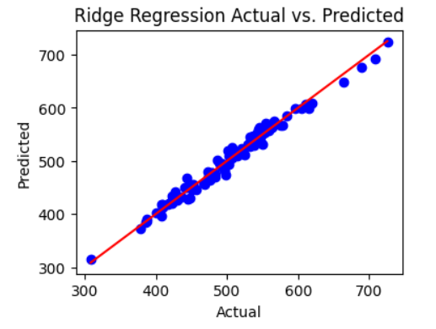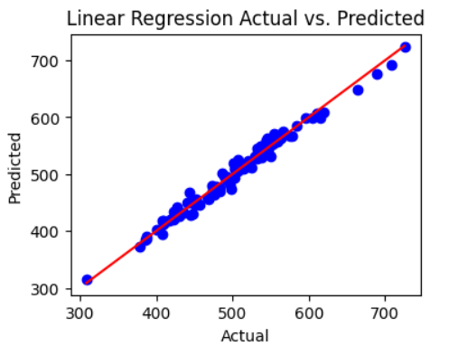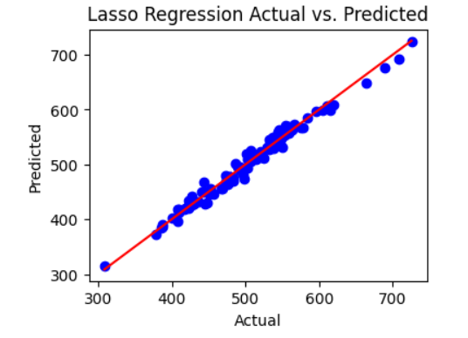

# Discussion:

* Linear Regression demonstrated the highest test score among all evaluated algorithms, indicating its effectiveness in predicting Yearly Amount Spent based on the given features.
* Despite its simplicity, Linear Regression performed competitively compared to more complex regression methods, such as Ridge, Lasso, and ElasticNet.
* The error ratio for Linear Regression was close to 1, suggesting a balanced performance between training and testing data, without significant overfitting or underfitting.

These findings suggest that Linear Regression is a suitable and effective approach for modeling the relationship between customer characteristics and their annual spending habits. However, further analysis and experimentation may be necessary to explore potential nonlinear relationships and additional factors influencing customer spending behaviour [11].

# Conclusion:

In this study, we investigated the effectiveness of various regression algorithms in predicting Yearly Amount Spent by customers of an e-commerce company based on their characteristics. The analysis involved the evaluation of four regression algorithms: Linear Regression, Ridge Regression, Lasso Regression, and ElasticNet Regression.

Our findings indicate that Linear Regression emerged as the best-performing algorithm, achieving a test score of 0.812 and demonstrating the ability to explain approximately 81.2% of the variance in the target variable. Despite its simplicity, Linear Regression exhibited competitive performance compared to more complex regularization techniques, such as Ridge, Lasso, and ElasticNet.

The evaluation also revealed that all algorithms demonstrated relatively similar performance, with test scores ranging from 0.808 to 0.812 and error ratios close to 1, indicating balanced performance between training and testing data without significant overfitting or underfitting.

These results suggest that Linear Regression is a suitable and effective approach for modeling the relationship between customer characteristics and their annual spending habits in the context of e-commerce. However, further investigation may be warranted to explore potential nonlinear relationships and additional factors influencing customer spending behavior.

Overall, this study provides valuable insights into the application of regression modeling techniques for understanding and predicting customer behavior in e-commerce settings, offering practical implications for marketing strategies, customer segmentation, and personalized recommendations.

# References:

1. [ML-basics](https://www.geeksforgeeks.org/machine-learning/)-https://www.geeksforgeeks.org/machine-learning/
2. <https://www.w3schools.com/python/python_ml_getting_started.asp>
3. <https://www.spiceworks.com/tech/artificial-intelligence/articles/what-is-ml/>
4. <https://www.javatpoint.com/linear-regression-in-machine-learning>
5. "Customer Spend Analysis: Definition, Prediction, and Calculate Spend." 09 Dec. 2022, <https://www.thomasnet.com/insights/customer-spend-analysis/>.
6. <https://bmcmedinformdecismak.biomedcentral.com/articles/10.1186/s12911-021-01403-2>
7. <https://www.researchgate.net/publication/338689095_Machine_Learning_based_Prediction_of_Customer_Spending_Score>
8. "Predicting Consumer Demand in an Unpredictable World." 26 Nov. 2020, <https://hbr.org/2020/11/predicting-consumer-demand-in-an-unpredictable-world>.
9. "US consumer spending: 2022 survey results | McKinsey." 04 May. 2022, <https://www.mckinsey.com/capabilities/growth-marketing-and-sales/our-insights/how-us-consumers-are-feeling-shopping-and-spending-and-what-it-means-for-companies>.
10. <https://www.kaggle.com/>
11. <https://pro.arcgis.com/en/pro-app/latest/tool-reference/geoai/how-linear-regression-works.htm>

### 